Leadership Table Meeting 1/15/18

Present for the Meeting: Annette Fisher, Carlos Ramirez, Carl Pojezny, Nancy Gowen-Nieser, Rick Poole, George Burton, Greg Self, Kyndel Leatherock, Dwayne Blakely, Dale Smith, Patti Pojezny, Elaine Robinson and Jenny Ferguson.

Elaine opened the meeting in prayer.

Minutes were approved for the previous two meetings of November 7, 2017 and December 15, 2017.

Greg Self gave the finance report:
- December was a good month.
- Our pledges are over for the year.
- Have spoken with people have not given what they said they would pledge.
- Approved of the new budget for 2018.
  - Able to give raises to employees that deserved it.
- Would like to create a new form of income for the church.
  - Thought of ideas like a Children’s Day Out
  - Looking at St. Lukes as a good model because they have a daycare. Would not start with a daycare but a good idea to keep in mind for the future and build towards.
- Financial goal for the year it to break even and be self suffiant.
- George motioned to approve Financial Report, Carl seconded and all in favor.

Trustee’s Report was emailed to Nancy by Reed Clifton.
- Hired Stanley Streamer to clean and scotch guard carpet and prayer rail cushions in Sanctuary for $476.80 after discount.
- Replaced blower motor for heater in room 104 closet- Vogt Heat and Air bill was $485.00.
- Will purchase vending machine that is currently in places for $500.00 with a 6 month warranty.
- Would like to clean and scotch guard the pew cushions at some point. Bid from Stanley Steamer is $1698.00.
- Goals for Trustee’s
  - Price new entry for NW doors leading to the nursery, to include portico.
  - Raise money for phase I of new sound system in Sanctuary, around $40,000.
  - New sign-waiting to hear from grant.
  - Bids to repair trim and paint the outside of the church.

Carlos went over new idea for the church logo.
- Very colorful logo and will most likely be printed in black and white most of the time.
- Would like to look at the previous logo without the high skyscrapers and more of a village/ OKC city view.
  - Carlos is going to work on that.
- Once previous idea’s logo is complete, going to have both printed in color and black and white and have the church vote on their favorite new logo.

After School Program Update from Annette and Carlos
- Decided on a name for the program they will be called “Village All Stars”
- Will work with third and fourth graders per the principals request and need of the school.
- Program will meet Monday, Tuesday and Wednesday.
- Any Spanish speaking students/ parents will be referred to Carolos.
- Will need to pay the leader with the grant money. Do not want to not have the position not budgeted for future purposes.
- Elaine made motion to have Annette do as she wants with the after school program. Greg seconds and all in favor.
- After this meeting Annette will report the after school program to missions.

Elaine gave the pastor’s report
- 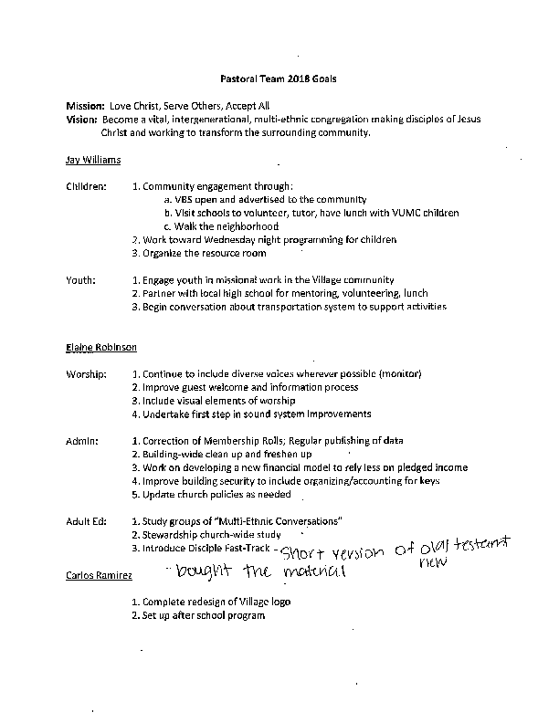There has been a lot of momentum the last 7 months with the new pastors in place.
- We received a grant to expand the Single Parent Network.
- Pastor’s Goals- See attachment provided by Elaine.

Leadership Table Goals for the year.
- Learn how to be a Leadership Table.
- Be the accountability for employees and committees.
- Quarterly review of goals from each committee, next review would be April.

Next Meeting is February 12, 2018 at 6:00 PM room 104.

Carlos closed in prayer.

